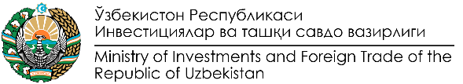 | 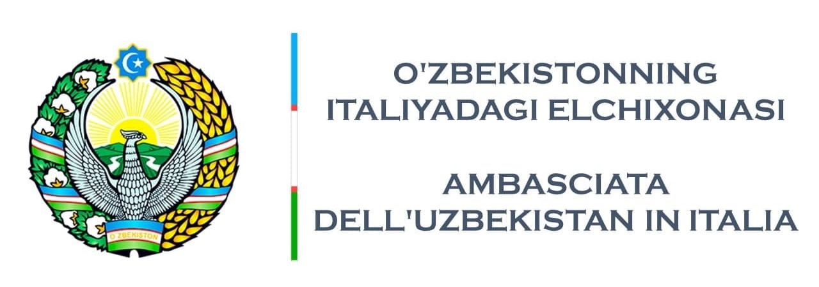

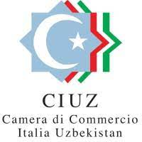

A Business Forum in Milan on Textile and Leather Cooperation
Italy – Uzbekistan

On 6 December, 2021 Business Forum on Textile and Leather Cooperation Italy – Uzbekistan will be held in “Aida” Conference Hall at Rosa Grand Hotel in Milan (Piazza Fontana, 3, 20122 Milano MI).

The Forum is organized by the Ministry of Investment and Foreign Trade of Uzbekistan jointly with the Embassy of Uzbekistan in Rome in cooperation with the Chamber of Commerce “Italy-Uzbekistan” (CIUZ) and the Italian Association of Small and Medium Entrepreneurs (CONFIMEA Imrpese).
The Business Forum will include presentations from Italian and Uzbek entrepreneurs who will share their successful experiences in trade and investment cooperation between two countries.
The leading 40 Uzbek companies representing textile, garment, leather and footwear industry are expected to participate in the Business Forum. They will be interested to present their businesses, explore possibilities for mutually beneficial cooperation with Italian partners in exporting their products, as well as in expanding and improving their production enterprises involving the advanced Italian technologies and know how.
The program of the Business Forum will also include B2B and B2G meetings, as well as exhibition of the products produced by Uzbek entrepreneurs.
Participation in the Business Forum is free of charge.
For additional information you can contact Mr. Abdulaziz Abduganiev, Councillor of the Embassy of Uzbekistan in Italy (tel. +39 06 877 75827, cell. +39 344 112 4141, email: consigliere@uzbekistanitalia.org).
Please fill in the attached form and send it, by 03/012/2021, to the attention of Mrs. Silvia Boz (silvia.boz@ciuz.info).
We would be delighted if your company is represented at the above Business Forum.
Business Forum will be held in accordance with COVID regulations.

