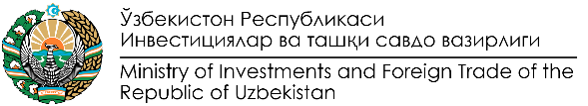

Programme of the Business Forum
on textile and leather cooperation
Italy – Uzbekistan
December 6, 2021 Milan, Italy

Venue – Rosa Grand Hotel (Piazza Fontana, 3, 20122 Milano MI)
“Aida” Conference Hall

Moderator – Giorgio Veronesi, Vice President of the Chamber of Commerce
Italy – Uzbekistan

10.00-10.10 | - | Welcome speeches by:  - Alan Christian Rizzi, Undersecretary on International Relations of the Lombardia Region Government  - Abdulaziz Abduganiev, councillor of the Embassy of the Republic of Uzbekistan in Italy
10.10-10.25 | - | Institutional cooperation  - Leonardo Comucci, Honourary Consul of Uzbekistan  in Toscana and Umbria  - Representative of CONFIMEA Imprese  - Luigi Iperti, President of the Chamber of Commerce  Italy – Uzbekistan (CIUZ)
10.25-11.10 |  | Presentations:  - “Uzbekistan Textile and Garment Industry. Opportunity  for sustainable cooperation”  Davron Vakhabov, First Deputy Chairman of the  Textile and Garment Industry Association  - “New opportunities and realities of the leather  and footwear and fur industry of Uzbekistan”  Farkhod Nurmukhamedov, Deputy Chairman of the  Leather Industry Association  - “A new stage of trade cooperation between  Uzbekistan and the EU countries”  Mirmukhsin Sultanov, Head of Light Industry  Department of the Ministry of Investments and Foreign  Trade of the Republic of Uzbekistan  - Interventions from Italian and Uzbek companies
11.10-11.30 | - | Coffee-break
11.30-13.00 | - | B2B and G2B meetings
13.00-14.00 | - | Reception on behalf of the Delegation of Uzbekistan
14.00-18.00 | - | B2B and G2B meetings

